**Step 1: Connect to Azure Cloud Shell**

1. Go to the [Azure Portal](https://portal.azure.com).

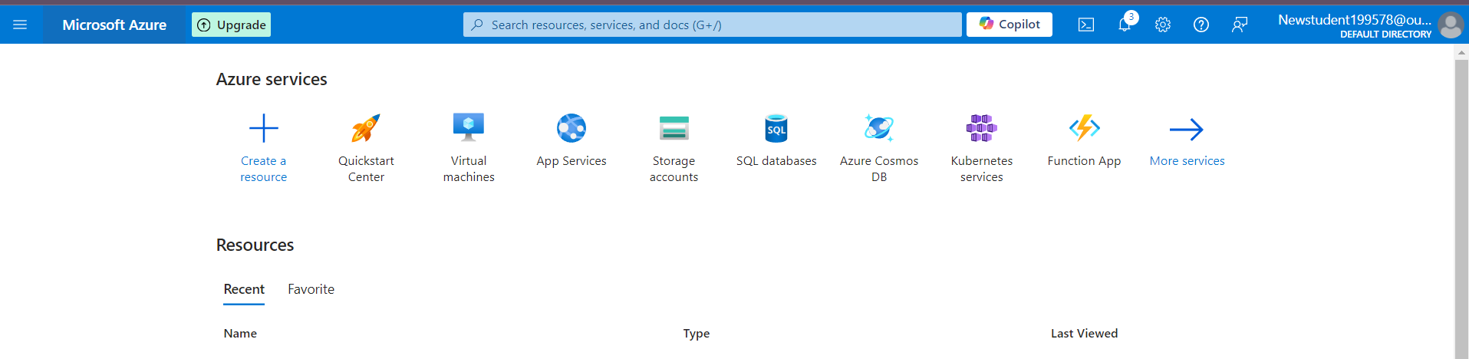

1. Click on the **Cloud Shell** icon (a terminal icon) at the top-right corner of the portal.

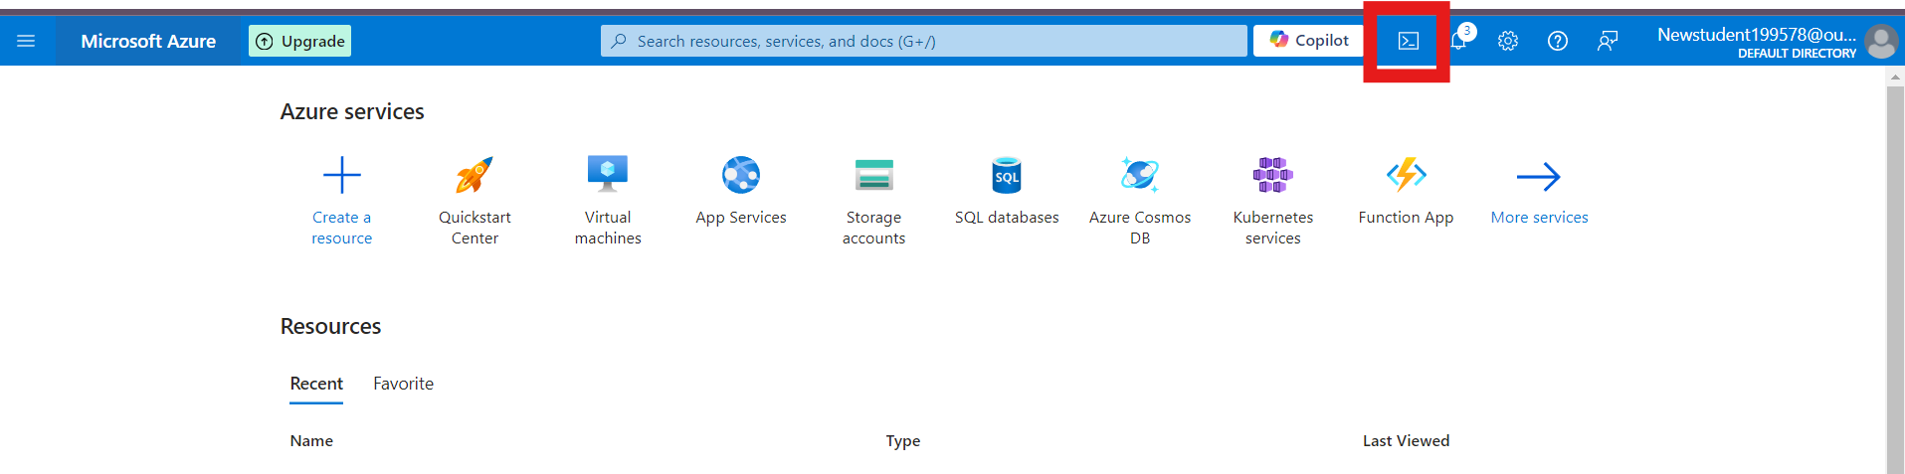

1. Select **PowerShell**.



1. The Cloud Shell will automatically connect to your Azure environment.

**Step 2: Create a Resource Group**

Once inside Cloud Shell:

**PowerShell:**

1. Run the following command to create the resource group:

**New-AzResourceGroup -Name "rg-1" -Location "South Central US"**

**1. Create 3 Storage Account**

**az storage account create --name shahidteam1 --resource-group rg-1 --location "South Central US" --sku Standard_LRS**

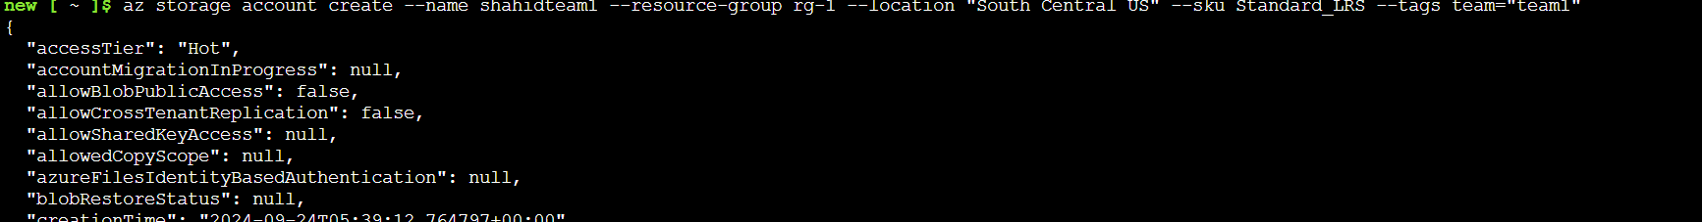

**2. Connect Azure Storage Explorer to This Storage Account**

**Steps:**

1. Download and install **Azure Storage Explorer** from the official website if you don't have it already.
   * Link: [Azure Storage Explorer](https://azure.microsoft.com/en-us/features/storage-explorer/)
2. Open **Azure Storage Explorer**.
3. Click on **"Add an Account"** in the left panel.
4. Select **"Azure"**
5. Sign in with your Azure credentials.
6. Once signed in, you should see all the storage accounts under your subscription.
7. Locate your newly created storage account (**shahidteam1**) and expand it to explore the containers, blobs, files, and other storage services.

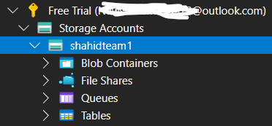

**1. Create a File Share using Storage Explorer**

1. Open **Azure Storage Explorer**.
2. In the left pane, under your subscription, find and expand your **Storage Account**.
3. Right-click on **File Shares** under your storage account.
4. Select **Create File Share**.
5. Enter a name for the file share (shahid199578fileshare), and click **OK**.
6. Once created, you can now see the file share listed under **File Shares**.

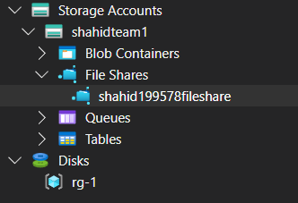

**2. Upload Files to the Blob Service**

1. In **Azure Storage Explorer**, under your **Storage Account**, expand **Blob Containers**.
2. Right-click on **Blob Containers** and select **Create Blob Container**.
3. Name the container (shahid199578blob) and click **OK**.
4. Once created, select the blob container, and you will see an **Upload** button on the top toolbar.
5. Click **Upload** > **Upload Files**.
6. Browse your local files and select the files you want to upload.
7. Click **Upload** to start uploading the files to the blob service.

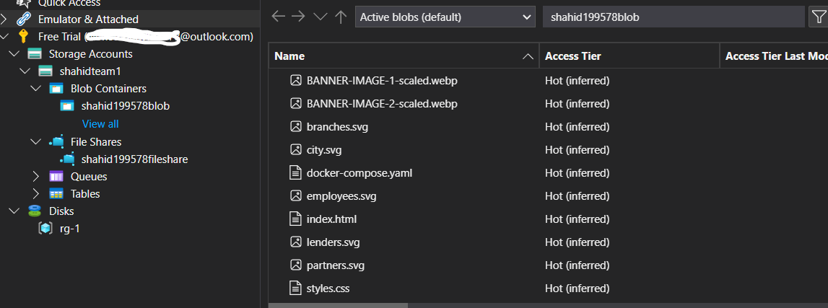

**3. Create an Azure Table and Insert a Record**

1. In **Azure Storage Explorer**, expand your **Storage Account** and right-click on **Tables**.
2. Select **Create Table**.
3. Name the table (shahid199578table) and click **OK**.
4. Once the table is created, click on the table to view it.

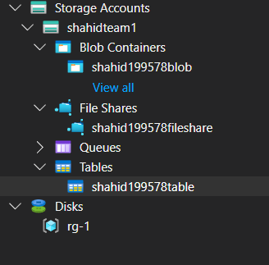

1. To insert a record:
   * Click on **Add Entity** in the toolbar.
   * Fill in the required fields (PartitionKey, RowKey,).
   * Click **Insert** to add the record.

